# CS 499 Module One Assignment

Complete this template by replacing the bracketed text with the relevant information.

1. **Self-Introduction:** Address all of the following questions to introduce yourself.
   1. How long have you been in the Computer Science program?

**I have been in the Computer Science program at SNHU since 2023 and have also been taking courses in Data Analytics.**

* 1. What have you learned while in the program? List three of the most important concepts or skills you have learned.

**Three of the important concepts or skills that I learned in my time of study were the workflow for how applications are developed in a professional environment, specifically the SCRUM workflow. Second, I learned about SQL and NoSQL databases and how to use them with my applications and what value that they bring to businesses that have large amounts of data that needs to be organized and manipulated. Finally, I learned about mobile application development, specifically for Android systems, which is very useful in the present day because the majority of devices in use by consumers are phones or tablets.**

* 1. Discuss the specific skills you aim to demonstrate through your enhancements to reach each of the course outcomes.

**The skills that I wish to show through the enhancements are my abilities to translate code from one language to another; my ability to create a functioning and useful GUI interface, and my ability to create and manage a database system for the application to get information out of and put information into.**

* 1. How do the specific skills you will demonstrate align with your career plans related to your degree?

**My career goal is to find a position that is more software development based, preferably focused on database integration into applications or even database administration. These skills will show that I have the ability to not only do the application development side with multiple languages, but also create and integrate a database system on the back end.**

* 1. How does this contribute to the specialization you are targeting for your career?

**This contributes to the specialization that I am targeting for my career because it shows my competency with application development and with database development. Being able to demonstrate that I can take existing code and add features, refining the application and improving it, is a good trait to show to future employers who will be looking for people who can improve their existing code base.**

1. **ePortfolio Set Up:**
   1. Submit a **screen capture** of your ePortfolio GitHub Pages home page that clearly shows your URL.
      1. You already have a repository in GitHub where you uploaded projects in previous courses. Your ePortfolio will reside in GitHub but can link to work at other sites, such as Bitbucket.
   2. Use the GitHub Pages link in the Resource section for directions on:
      1. How to create your GitHub website and publish code to GitHub Pages
      2. Issues, such as adding links to other sites
   3. Paste a screenshot of your GitHub Pages home page with your URL clearly showing in the space below.

1. **Enhancement Plan:** 
   1. **Category One:** Software Engineering and Design
      1. **Select an** **artifact** that is **aligned with** **the** software engineering and design **category** and explain its origin. Submit a file containing the code for the artifact you choose with your enhancement plan.

**The artifact that I have chosen for enhancement in this category is the slideshow application that I created in CS 250: Software Development Lifecycle. For my enhancement I will be rewriting the application in C#, redesigning the UI and adding a feature that allows users to login and have a list of their favorite travel destinations. The original application was a demonstration of the software development lifecycle and created a list of the top five travel destinations that a travel company was selling.**

Note: Your artifact may be work from the following courses:

* IT 145: Foundation in Application Development
* CS 250: Software Development Lifecycle
* CS 260: Data Structures and Algorithms
* IT 315: Object Oriented Analysis and Design
* CS 320: Software Testing, Automation, and Quality Assurance
* CS 330: Computational Graphics and Visualization
* CS 340: Advanced Programming Concepts
* CS 350: Emerging Systems Architectures and Technologies
* CS 360: Mobile Architecture and Programming
* IT 365: Operating Environments
* IT 380: Cybersecurity and Information Assurance
* CS 405: Secure Coding
* CS 410: Reverse Software engineering
* IT 340: Network and Telecommunication Management
* IT 380: Cybersecurity and Information Assurance
  + 1. **Describe** a practical, well-illustrated **plan** for enhancement in alignment with the category, including a pseudocode or flowchart that illustrates the planned enhancement.

To begin this enhancement I will have to look at the C# language and compare the methods to Java, which is the original language. I will need to set up a development environment for C# development and then start building an application with similar functionality to the original application. During this process I also have to add functionality for the user login and managing the favorites so that only the favorites of the logged in user are visible. The User will first be presented with a login screen that will allow them to either log in or make a new user. From there they will see a screen that shows all of the available travel destinations with the option to select them to see more, and the option to favorite the destination. The user will be able to select a favorites button in order to see the destinations that they have favorited.

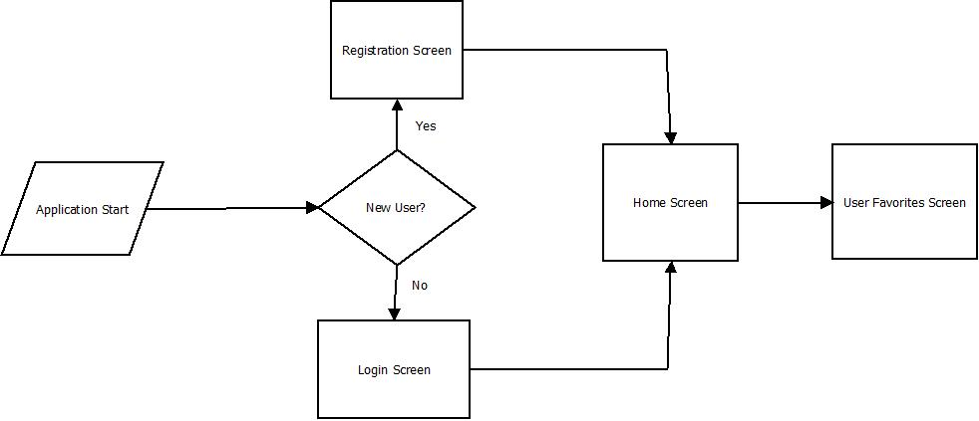

For this category of enhancement, consider improving a piece of software, transferring a project into a different language, reverse engineering a piece of software for a different operating system, or expanding a project’s complexity. These are just recommendations. Consider being creative and proposing an alternative enhancement to your instructor.

Think about what additions to include to complete the enhancement criteria in this category. Since one example option is to port to a new language, that is the kind of scale that is expected. This does not mean you need to port to a new language but instead have an equivalent scale of enhancement. Underlying expectations of any enhancement include fixing errors, debugging, and cleaning up comments, but these are not enhancements themselves.

* + 1. Explain how the planned enhancement will **demonstrate** specific **skills** and align with course outcomes.
       1. Identify and describe the specific skills you will demonstrate that align with the course outcome.

**The skills that this will represent are my ability to take an application and recreate it in a different language, and also expand the functionality of that application to include the saving of user data and the ability to log into the application.**

* + - 1. Select one or more of the course outcomes below that your enhancement will align with.

**This application will definitely allow me to design and design and evaluate computing solutions to solve a given problem, as I will be looking through C# and determining what will need to be done in that language in order to achieve the same result. I will also strive to demonstrate the ability to use well-founded and innovative techniques, skill, and tools as I change my coding environment to Visual Studio from Eclipse and work to discover and understand the class .net framework class libraries for application development. The redesign of the UI using C# will allow me to focus on delivering the professional quality written and visual communication that audiences desire.**

Course Outcomes:

1. Employ strategies for building collaborative environments that enable diverse audiences to support organizational decision-making in the field of computer science.
2. Design, develop, and deliver professional-quality oral, written, and visual communications that are coherent, technically sound, and appropriately adapted to specific audiences and contexts.
3. Design and evaluate computing solutions that solve a given problem using algorithmic principles and computer science practices and standards appropriate to its solution while managing the trade-offs involved in design choices.
4. Demonstrate an ability to use well-founded and innovative techniques, skills, and tools in computing practices for the purpose of implementing computer solutions that deliver value and accomplish industry-specific goals.
5. Develop a security mindset that anticipates adversarial exploits in software architecture and designs to expose potential vulnerabilities, mitigate design flaws, and ensure privacy and enhanced security of data and resources.
   1. **Category Two:** Algorithms and Data Structures
6. **Select an artifact** that is **aligned with the** algorithms and data structures **category** and explain its origin. Submit a file containing the code for the artifact you choose with your enhancement plan. You may choose work from the courses listed under Category One.

**For this category I will be using the same artifact that I used for the previous enhancement, the slideshow project from CS 250: Software Development Lifecycle.**

1. **Describe** a practical, well-illustrated **plan** for enhancement in alignment with the category, including a pseudocode or flowchart that illustrates the planned enhancement.

**The enhancements to the algorithms and data structures of this application will come about because I will be moving much of the data for travel locations onto a database and using ADO.NET to connect the C# application to a SQL database. This means that the C# application itself will be retrieving information from the SQL database server, which means that data can be easily added, removed, or modified at will. This also will allow for the user account information to be integrated into the application for user login. I also will be adding sorting algorithms so that the list of travel destinations on the main page can be sorted according to name, date, or rating.**

1. **Application Starts**
2. **If user is new user**
   1. **Open dialog and allow user to enter new username and password**
   2. **Hash password**
   3. **Add entry in database with new username and hashed password**
3. **If user is not new user**
   1. **Show login screen**
   2. **Allow user to input username and password**
   3. **Password is hashed**
   4. **Compare username and hashed password to username and password in database**
   5. **If the same**
      1. **Allow login**
   6. **If not the same**
      1. **Tell user the username or password are incorrect**
      2. **Allow user to retry**
4. **If user logged in**
   1. **Access database to get information on all travel destinations**
      1. **Initially sort information alphabetically**
      2. **Display information in UI**
      3. **Allow user to hit buttons to change order to by date**
         1. **If hit then refresh screen to show new order**
   2. **Have favorites tab that shows travel destinations that have been liked by the user**
      1. **Access database and only return travel destinations liked by user**

For this category of enhancement, consider improving the efficiency of a project or expanding the complexity of the use of data structures and algorithms for your artifact. These are just recommendations. Consider being creative and proposing an alternative enhancement to your instructor. Note: You only need to choose one type of enhancement per category.

Think about what additions to include to complete the enhancement criteria in this category. Since one example option is to port to a new language, that is the kind of scale that is expected. Perhaps you might increase the efficiency and time complexity of an algorithm in an application and detail the logic of the increased time complexity. Remember, you do not need to port to a new language but instead have an equivalent scale of enhancement. Underlying expectations of any enhancement include fixing errors, debugging, and cleaning up comments, but these are not enhancements themselves.

1. Explain how the planned enhancement will **demonstrate** specific **skills** and align with course outcomes.
   1. Identify and describe the specific skills you will demonstrate to align with the course outcome.

**The skills I will demonstrate are increasing the efficiency of the application by using a database to handle much of the information that the application uses. I also will show my experience with sorting algorithms as I use one to sort the travel destinations on the main page of the application.**

* 1. Select one or more of the course outcomes listed under Category One that your enhancement will align with.

Designing, developing, and delivering professional-quality oral, written, and visual communications that are coherent, technically sound, and appropriately adapted to specific audiences and contexts is one skill that this area helps with because I will be giving more control over to the user for determining how they want the information to be sorted and presented to them in the application. The security of the application is also a part of this as the login screen requires the username and password of the user to be entered and to be correct before they can access their account.

* 1. **Category Three: Databases**
     1. **Select an artifact** that is **aligned with the** databases **category** and explain its origin. Submit a file containing the code for the artifact you choose with your enhancement plan. You may choose work from the courses listed under Category One.

**Once again I will be using the artifact from CS250: Software Development Lifecycle in order to demonstrate this enhancement. I will be creating a SQL database that will store two major types of information: information on the users of the application as well as information on the types of travel locations available to the users. The user information will include the username, email, and hashed password information. The travel locations will include the travel location name, date of departure and arrival, an image associated with the travel location, and any other information related to the travel location that is necessary. The information will be delivered to the application via the ADO.NET class library.**

* + 1. **Describe** a practical, well-illustrated **plan** for enhancement in alignment with the category, including a pseudocode or flowchart that illustrates the planned enhancement.

The SQL database will be broken up into three tables. The user table will have the username and hashed password of the user, and the primary key of the userID. The Destination table will have information on the travel destination including the name of the destination, the date of the trip, a description of the destination, an image of the destination, and the primary key will be the destID. Finally a UserDestination table will be used in order to connect the User and Destination tables and prevent a many-to-many relationship. This table will be used to keep track of users who have favorited certain destinations and the destinations that they favorited.

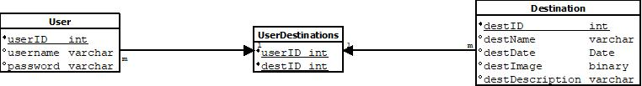

For this category of enhancement, consider adding more advanced concepts of MySQL, incorporating data mining, creating a MongoDB interface with HTML/JavaScript, or building a full stack with a different programming language for your artifact. These are just recommendations; consider being creative and proposing an alternative enhancement to your instructor. Note: You only need to choose one type of enhancement per category.

Think about what additions to include to complete the enhancement criteria in this category. Since one example option is to port to a new language, that is the kind of scale that is expected. Perhaps you might increase the efficiency and time complexity of an algorithm in an application and detail the logic of the increased time complexity. Remember, you do not need to port to a new language but instead have an equivalent scale of enhancement. Underlying expectations of any enhancement include fixing errors, debugging, and cleaning up comments, but these are not enhancements themselves.

* + 1. Explain how the planned enhancement will **demonstrate** specific **skills** and align with course outcomes.
       1. Identify and describe the specific skills you will demonstrate that align with the course outcome.

**For this enhancement I will be demonstrating my ability to create a SQL database that is normalized and has correctly connected tables with the required information. I will also be showing my skills in the ability to connect SQL to C# and query the SQL information from the C# application, including the travel information and the user information.**

* + - 1. Select one or more of the course outcomes listed under Category One that your enhancement will align with.

**The introduction of a database to this application will make it much easier for collaboration between diverse groups within the organization, as changes to the travel information can be made my simply updating the database and not having to recode the C# application itself. The flexibility of this approach allows the application’s information to be scaled up or down easily.**

1. **ePortfolio Overall Skill Set**
   1. Accurately describe the **skill set** to be illustrated by the **ePortfolio** **overall**.
      1. Skills and outcomes planned to be illustrated in the code review

**The main skill I want to show in the code review is how the application was made more efficient, not only in the retrieval of information but also in the ability to easily modify, add, and remove travel destination information. I also want to show the redesign of the application through the porting of the code to C# and how I have skills in the usage of this language.**

* + 1. Skills and outcomes planned to be illustrated in the narratives

**For the narratives I would like to show how the security of the application was implemented by using a hashing algorithm to hash the password before storage in the SQL database. I also want to show how I can create a user interface using C# and make the interface design one that can appeal to a large audience through the text and visual placement.**

* + 1. Skills and outcomes planned to be illustrated in the professional self-assessment

**I want to show my skill in being given a problem and being able to master the problem and determine the best solution for it. I also want to show that I understand multiple different programming languages and can use them together in order to get the job accomplished. I want to show organization in my work, and organization in how the data is assembled in the database.**